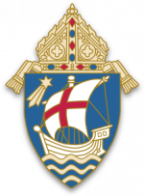 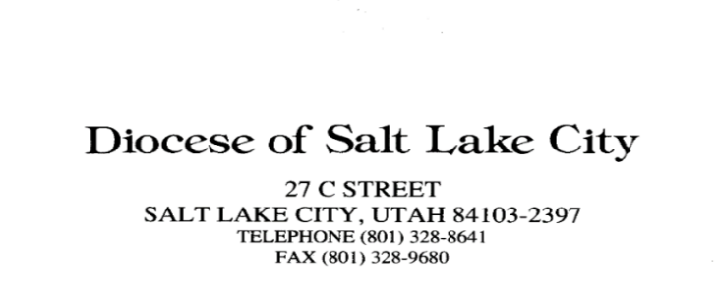

**Personal Assessment of Ministry/Canonical Appointment**

**2024 - 2025 Survey**

* To recite every day at least part of the Divine Office (Liturgy of the Hours); be reminded that morning and evening prayer are obligatory for all deacons and 10 hours of Continuing Formation.

*Do you pray the Divine Office (Liturgy of the Hours) daily for the Church and the world?*

* All deacons at the age of 70 or over are to submit a letter of retirement. If you are still serving, please fill out the form and let us know what ministries you are doing. At the age of 70, a deacon should begin dialogue with his pastor to consider whether to request an extension of the canonical appointment and to plan for the future. An updated Contract of Understanding (COU) will be required before an extension of the canonical appointment is granted.

*If you have already attained the age of 70, have you submitted your annual letter of retirement as required? Do you intend to ask for an extension of your appointment?*

**What is your status as a Deacon**

* Fully Active
* Semi-Active
* Retired with Faculties
* Retired without Faculties

**What is your ethnicity?**

* Hispanic/Latino
* Asian/Pacific Islander
* Black
* Native American
* Anglo
* Other (Please indicate)
* Prefer not to answer

**What is your highest level of education:**

* Less than High School
* High School/GRE
* Associate Degree
* Bachelor Degree
* Masters Degree
* Doctorate

**If you have a college degree(s), is it in Theology, Religious Studies, Pastoral Ministry, Pastoral Administration, or other area related to Church ministry? If so, please indicate below.**

***Please return this form by September 13, 2024, via e-mailed to mirnagomez@dioslc.org***

Name (print): ________________________________________ Date: ____________________

Signed: __________________________________